**Problem 1: [15]**

You have to create the following inheritance hierarchy.

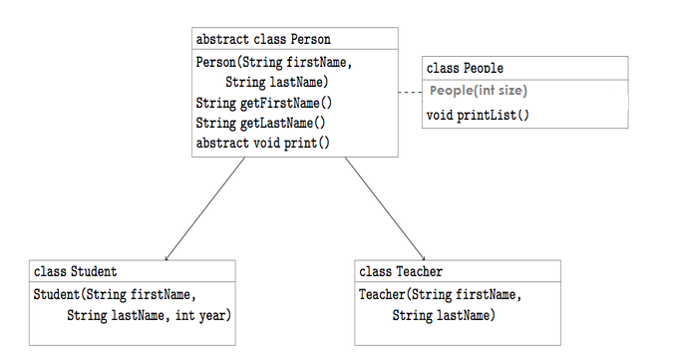

* Create an abstract class Person that implements the mentioned methods. A person should have a given first name and last name. It should also be possible to print person’s full name. **[2]**
* Create the Teacher and Student classes that inherit from Person. In addition to a name, Students should have a current year in school. You can add more data members for Teacher as well e.g. String SpecializationSubject. Printing a Teacher or a Student should show this additional information as well**.[3]**
* Write a class People that will keep the list of students and teachers. For this you have to take an array ( Person[] array) as class member, take size of this array as input from user. It will also be capable of printing a list of all of the people**. [4]**
* In main method **[6]**
  + Create an object of class People by taking the size of array as input from user (let’s say user entered N).
  + Now ask user if he wants to add teacher’s or student’s information, then take the information and save it to People object’s array. (Repeat this step N times to fill the array)
  + In the end, call printList() to display the array.

**Problem 2: [10]**

Copy the following code **[1]** and try to run it to find out if some exception occurs? If so, answer the following Questions:

1. Which Exception it throws exactly? **[1]**
2. Is that checked exception or unchecked exception? Why are you calling it checked or unchecked? Also, appropriate write try catch finally blocks to handle these exceptions.**[2]**

|  |
| --- |
| import java.io.*;  public class Test  {  public static void main(String[] args1)  {  File f=new File("D:\\JavaExceptionHandling.txt");  FileInputStream fis=new FileInputStream(f);  }  } |
| public class Test  {  public static void main(String[] args)  {  int[] ar={1,2,3};  System.out.print(ar[5]);  }  } |
| import java.sql.*;  public class Test  {  public static void main(String[] args)  {  Class.forName("com.mysql.jdbc.Driver");    }  } |

1. Use inheritance to create an exception super class named exceptionA. Create two more exception classes (exception, exception) such that exceptionA is parent of exceptionB and exceptionB is parent of exceptionC.

Create Test class and write main in it to demonstrate that the catch block for type ExceptionA catches exceptions of exceptionB and exceptionC as well. **[6]**

**Note:** In your user defined exception classes, you are not required to override any methods, you are required to write constructors only, for this task.

**Problem 3: [10]**

1. Open Mysql (either through commandline)
2. Create a database named MyDB. (***command:*** *create databse MyDB*)
3. Create a table named “**Accounts**” in MyDB. (
4. Accounts table should have 2 columns

**Coumnn1 Name:** username, **Column1 type:** varchar(50)

**Column2 Name:** password, **Column1 type:** varchar(50)

(***command:*** *create table Accounts (username varchar(50), password varchar(50))*)

Run the following query to add some data to accounts table:

|  |
| --- |
| insert into Accounts (username, password) values (‘user1’, ‘password1’);  insert into Accounts (username, password) values (‘user2’, ‘password2’);  insert into Accounts (username, password) values (‘user3’, ‘password3’); |

Now you create a java application:

In main method, you have to establish connection with database then

* get all the users from accounts table and display it on console.
* Take a name as input from user and display the password for that username ( hint: use where clause in select).